# Introduction

I recently moved to Osaka, Japan. As someone who has been an Airbnb host for more than 4 years, I aim of hosting on Airbnb in multiple cities around the world to allow as many travellers to travel to have local experience, have a home away from home, and at the same time have all that experience for affordable prices.

Osaka is Japan's second largest metropolitan area after Tokyo. It has been the economic powerhouse of the Kansai Region for many centuries. Over 9.4 million foreign tourists visited Osaka last year, the largest number ever, Osaka tourism authorities announced. The figure represents a 31 percent increase on 2015, and is more than triple the number of foreign nationals who visited the city in 2013, officials added. Osaka has a lot of tourist attractions, but most importantly, Osaka is known as “Japan’s kitchen” and many food enthusiasts come here just to eat. Osaka is famous with its street food. These are takoyaki, okonomiyaki, fugu, kushikatsu, yakiniku. You can find these five foods well represented all over the city, but Umeda, Dotonbori, and Shinsekai are the biggest gourmet areas with the most famous restaurants.

In this report, I’ll get data from different sources to find the best neighborhood/ward to host my Airbnb in.

# Data sources

In my report, I’ll be getting my data for all the neighborhoods of Osaka from <https://en.wikipedia.org/wiki/Category:Wards_of_Osaka>

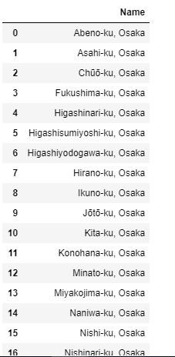

The coordinates (latitude and longitude) are from Open Street Map APIs: <http://nominatim.openstreetmap.org/search.php?q=>

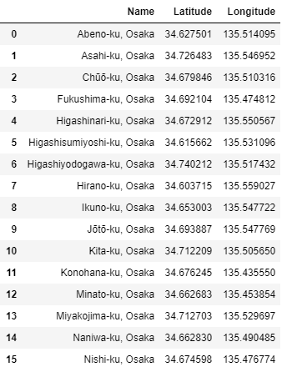

In addition, I’ll be using Foursqaure’s API to get the following venue data:

Historic Site

4deefb944765f83613cdba6e

Theme Park

4bf58dd8d48988d182941735

Ramen Restaurant

55a59bace4b013909087cb24

Okonomiyaki Restaurants

55a59bace4b013909087cb18

# Methodology

There are 23 wards in Osaka. Tourists from all over the world come to Osaka for different reasons. Some come to eat, others come for Themes are such as Disney land, and others to check historic sites. I chose for categories in which its data are collected from Foursquare’s API. These categories are: Historic sites, Theme parks, Ramen restaurants, and Okonomiyaki restaurants. The latter two are famous in the city and I thought to include them in as factors for my decision making.

To make a decision, I’ve calculated the number of venues in each category per ward. I have then come up with a score matrix to give each category a weighted number. For example: Historic sites are 2 since it attracts tourists, and tourists lean towards looking for place to rent besides historic sites. This resembles the importance of each category. Finally, the sum of score was calculated for all the venues from all the categories per ward to determine the suggested ward to host the Airbnb at.

# Analysis

I also used Map Folium to locate the wards and venues on the map:

# Wards

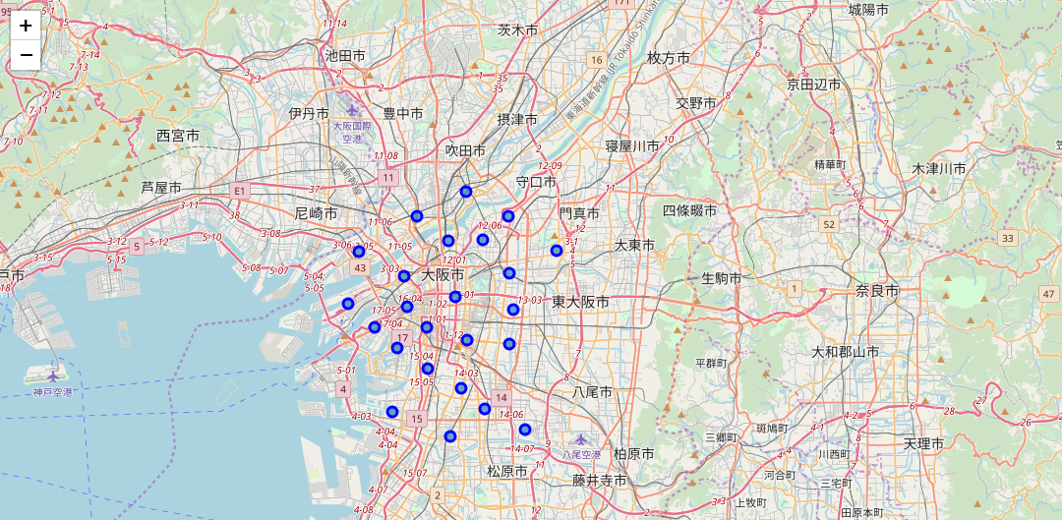

## Historic Sites Venues

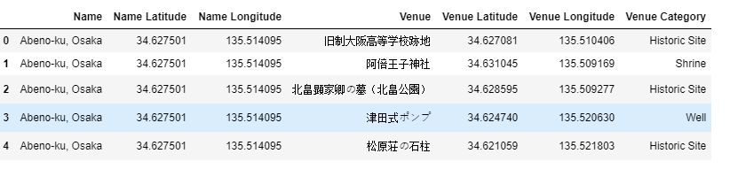

## Theme Park Venues

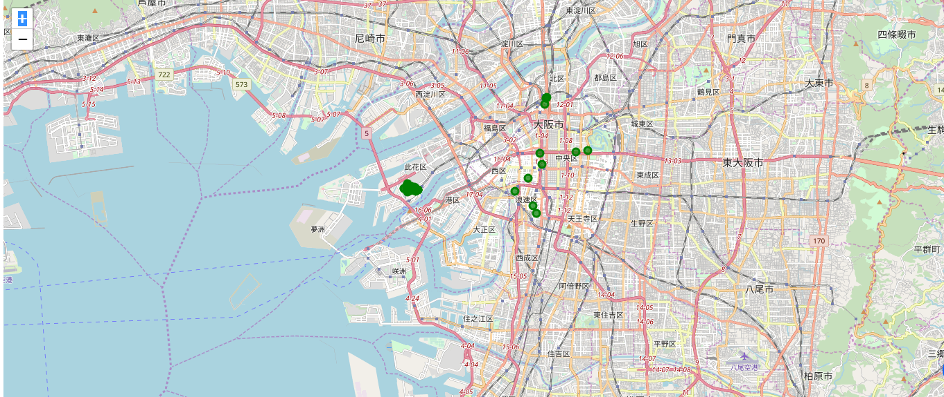

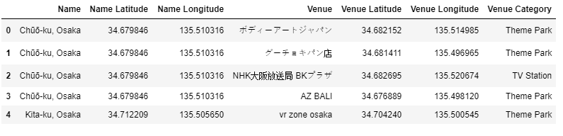

## Ramen Restaurants Venues

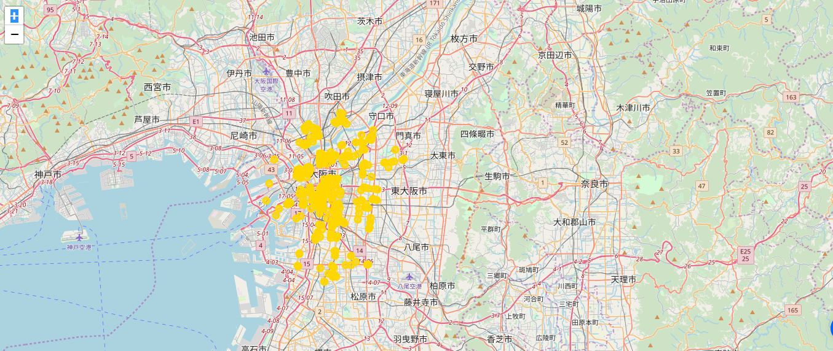

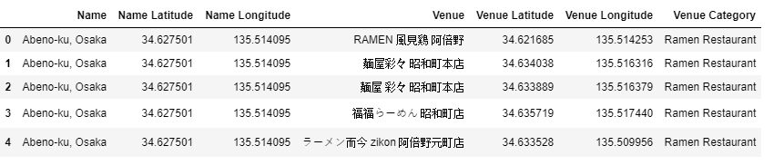

## Okonomiyaki Restaurants Venues

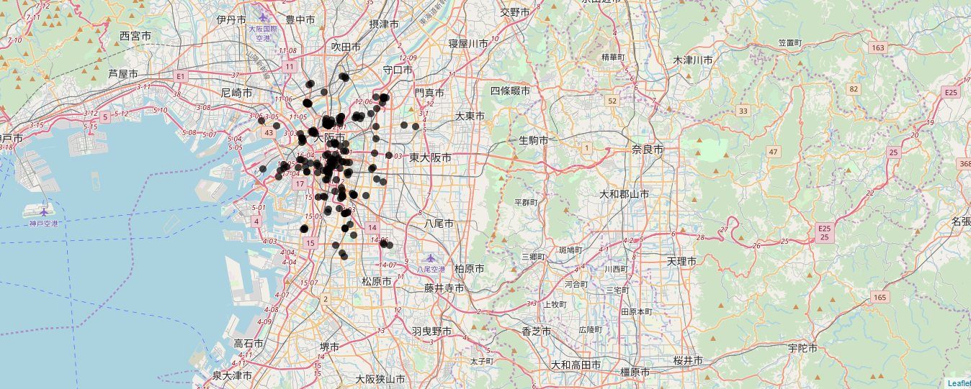

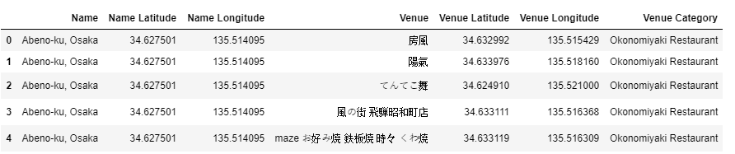

# Sum of Venues per Category per Ward

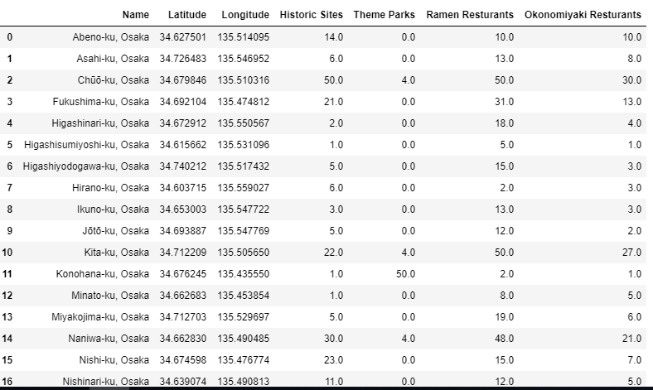

# Conclusion

Thee sum of score was calculated for all the venues from all the categories per ward to determine the suggested ward to host the Airbnb at. Therefore, Chuo ku Ward is our best and recommended ward to host our Airbnb rental at since it has the most historic sites, Theme parks, restaurants, and tourists will most likely would want to stay there as it’s close to all touristic attractions.